Report on the outcomes of a Short-Term Scientific Mission

Action number: CA18212
Grantee name: Veljko Vujčić

Details of the STSM
Title: New dataset for molecular ions of astrophysical importance
Start and end date: 08/12/2023 to 23/12/2023

Description of the work carried out during the STSM
Description of the activities carried out during the STSM. Any deviations from the initial working plan shall also be described in this section.
(max. 500 words)
Atomic and molecular (A&M) datasets provide fundamental information about the properties, behaviour, and interactions of atoms and molecules. As such, these datasets play an important role in various scientific and technological fields. One of the scopes of this Action is the research of molecules and molecular processes of astrophysical importance. A&M data can be used to model and understand the processes occurring in stars, including nucleosynthesis, radiation, and the formation of complex molecules in space. Also, information about molecular interactions is important for studying the composition and behaviour of the interstellar medium.
Nowadays, accurate spectroscopy opens possibility of finding and analysing small molecules in the abovementioned astronomical environments. The need of accurate optical and collisional data is crucial for these areas of scientific research. In this STSM, we investigated optical (photodissociative) processes of small molecular ions like CaH+, which are the components of interstellar clouds as well as some stellar atmospheres. We give cross section datasets for the mentioned hydrides, for the range of parameters which cover modeling of abovementioned environments.
The accessibility of scientific datasets is of importance in building robust scientific knowledge base. It also fosters collaboration among researchers, interdisciplinary collaboration, and innovation and technological development. In this STSM, we worked on transforming raw calculated data (partial cross sections) into a dataset that fits into a data model suitable for machine readable serialization. We published online a dataset consisting of 726 photodissociative reactions for CaH+ in various molecular quantum number states, as a list of partial cross sections, each one over 151 wavelengths (around 110,000 cross sections in total). Results can be obtained both via Serbian Virtual Observatory website and VAMDC portal for synchronized distributed queries. Output is serialized in form of XML structure (XSAMS) which is a standard in the A&M scientific community.
Description of the STSM main achievements and planned follow-up activities
Description and assessment of whether the STSM achieved its planned goals and expected outcomes, including specific contribution to Action objective and deliverables, or publications resulting from the STSM. Agreed plans for future follow-up collaborations shall also be described in this section.
(max. 500 words)
The results of this STSM match following MD-GAS keywords / objectives / deliverables:
- gas phase molecular dynamics
- ionization and molecule destruction
- to develop a new physical and chemical toolbox to significantly advance the understanding of: Gas phase molecular dynamics induced in interactions between molecules or clusters and photons, electrons, or heavy particles. Its consequences for a broad range of applications in e.g. astrochemical and atmospheric sciences, and molecular radiation damage;
- promote new collaborations between theoreticians and experimentalists to develop the new computational tools needed to accurately describe gas phase molecular dynamics;
- coordinate efforts to develop a detailed understanding of the destruction and growth of molecules and for charge transfer at collision energies and internal temperatures relevant for astrophysics/chemistry and the atmospheric sciences;
- establish a multidisciplinary research network;
- publish and present Action results in high impact journals and at in-field, nearby-field, and interdisciplinary conferences;
- act as an interdisciplinary platform for close collaborations and knowledge exchange between researchers from fundamental chemical physics and physical chemistry (experiment and theory) and applied sciences (astrophysics/chemistry, astronomy, atmospheric science, and radiation science), and with other key stakeholders from industry.
We published new dataset with photodissociation processes (partial and average cross sections) of calcium monohydride ion, which is now included in SerVO (Serbian Virtual Observatory) data center. The dataset is part of MolD database and web service, dedicated to photodissociation processes, which also functions inside VAMDC e-ecosystem and is accessible for online query both via VAMDC distributed queries and servo.aob.rs. Our plan is to publish the datasets in the MDPI open access journal Data. We will start writing draft with the host, prof. Radoslav K. Zamanov, for a leading astrophysical journal (such as Advances in Space Research).

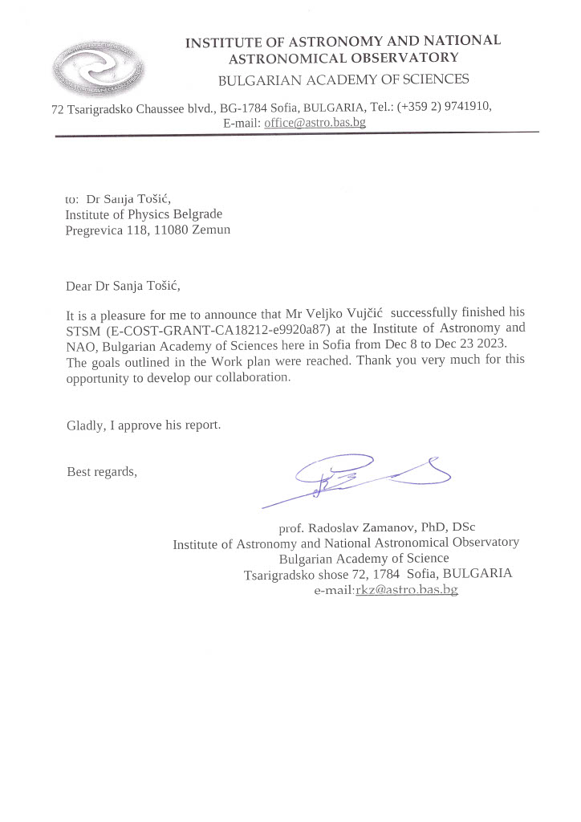

This report is submitted by the grantee to the Action MC for approval and for claiming payment of the awarded grant. The Grant Awarding Coordinator coordinates the evaluation of this report on behalf of the Action MC and instructs the GH for payment of the Grant.

